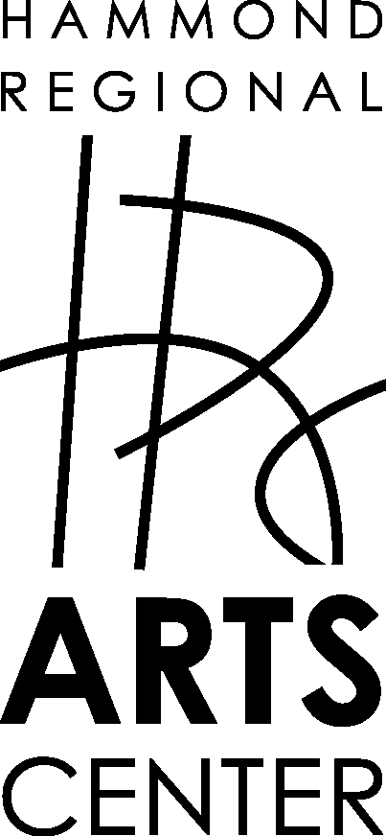
217 E. Thomas St
PO Box 2974
Hammond, LA 70404
info@hammondarts.org
985.542.7113

Exhibition Contract Agreement

This is an agreement between the Hammond Regional Arts Center (HRAC), 217 East Thomas
Street, Hammond, LA 70401, and_____________________________________(artist or arts organization).

The terms of the agreement are as follows:

☐ Any and all exhibition requests must be approved and scheduled by the HRAC Gallery Review Committee. The Gallery Review Committee may originate exhibitions. In which case, the Gallery Review Committee shall curate or appoint a curator for the exhibition.

☐ The exhibitor named above hereby contracts with HRAC as a non-exclusive agent for the exhibition of works of art as described in the Exhibition Inventory. Such Inventory, (indicating title, date of execution, media and size, insurance value and/or sales price of each work of art in the exhibition) is to be delivered to HRAC with the works of art to be exhibited. In addition, images of all work will be included unless otherwise agreed upon.

☐ The exhibitor warrants that the works of art in this contractual exhibition are original creations. As a community arts center HRAC reserves the right of final selection of works for inclusion in the exhibition that it will present. Unless otherwise agreed upon, works of art in an exhibition must remain in the exhibition for the time period indicated in the Exhibition Schedule.

☐ Works of arts in the exhibition that are for sale will be sold at a commission of 35% to HRAC. As a not-for-profit organization, commission of sales helps fund HRAC. The commission shall apply to all works of art listed for sale, to awards and prizes that include the sale of a given work of art. HRAC offers certain member discounts that will not apply to monies received by the exhibitor. Payment to the exhibitor will be made within thirty (30) days after the close of the exhibit.

☐ All works of art in any exhibition must be appropriately framed with screw eyes and wire. Free-standing sculpture will be subject to weight limits. Table-top pieces may be limited to available display equipment. The exhibition curator shall be responsible for installation with the assistance of available HRAC staff unless otherwise indicated in this agreement.

☐ Unless otherwise specified the exhibitor is responsible for the delivery and removal of all works exhibited on the dates indicated in Exhibition Schedule. Exhibited works of arts shall be insured according to the values listed in in the Exhibition Inventory of HRAC while in the possession of HRAC.
☐ HRAC shall have the right to produce/reproduce images of the art in an exhibition for purposes of advertising and promotion.

☐Exhibition Schedule

Title of Exhibition: __________________________________________________

Artist/Exhibitor: _________________________________________ (name)

Mailing Address (for payment in the event of a sale)

_______________________________________________________________

_______________________________________________________________

_______________________________________________________________

Cell Phone: ____________________________________________________

Email Address: _________________________________________________

Installer: ________________________________________________ (name)

Calendar:

_______ Date of Delivery (All art and the Exhibition Inventory)

_______ Dates of Exhibition

_______ Date of Reception

_______ Promotional Materials due

_______ Pick up artwork

☐ Any items not picked up by ______________ (date) become the property of HRAC.

☐ HRAC shall advertise and promote a given exhibition as determined by the Executive Director. HRAC will provide sufficient invitations (electronic and/or mail) to its membership and shall provide drinks and refreshments for the opening reception and for a "gallery talk"(if included).

☐ Should a contracted exhibitor cancel the exhibition within 90 days of the date of the exhibition or fail to deliver the exhibition on the assigned date, the exhibitor shall be responsible for any and all funds expended by HRAC regarding the exhibition.

☐ Should a contracted exhibitor make any alterations to the proposed exhibition or should one party in a group exhibition be excluded from that exhibition, HRAC reserves the right to re-evaluate and approve/cancel the revised exhibition.

☐ Any and all materials produced for the exhibition must be reviewed and approved by the HRAC Executive Director.

☐ Amendments, (which must be attached to this document), may be made to this contract as agreed upon by the Gallery Review Committee and the Exhibitor with the approval of the Executive Director.

☐ This contract/agreement is valid only when signed and dated by both the exhibitor and the authorized Hammond Regional Arts Center representative. Any dispute arising during this agreement shall be resolved pursuant to the Louisiana Arbitration Act.

Signed:

________________________________________________ /________________
Exhibitor date

_________________________________________________/_______________
Authorized representative of HRAC date

